Task 1.1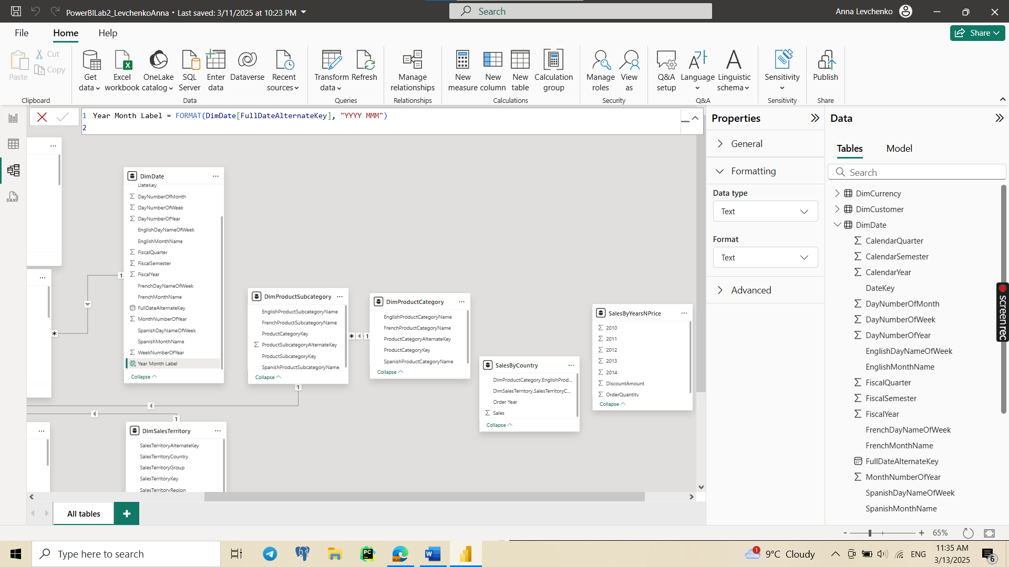

Task 1.2

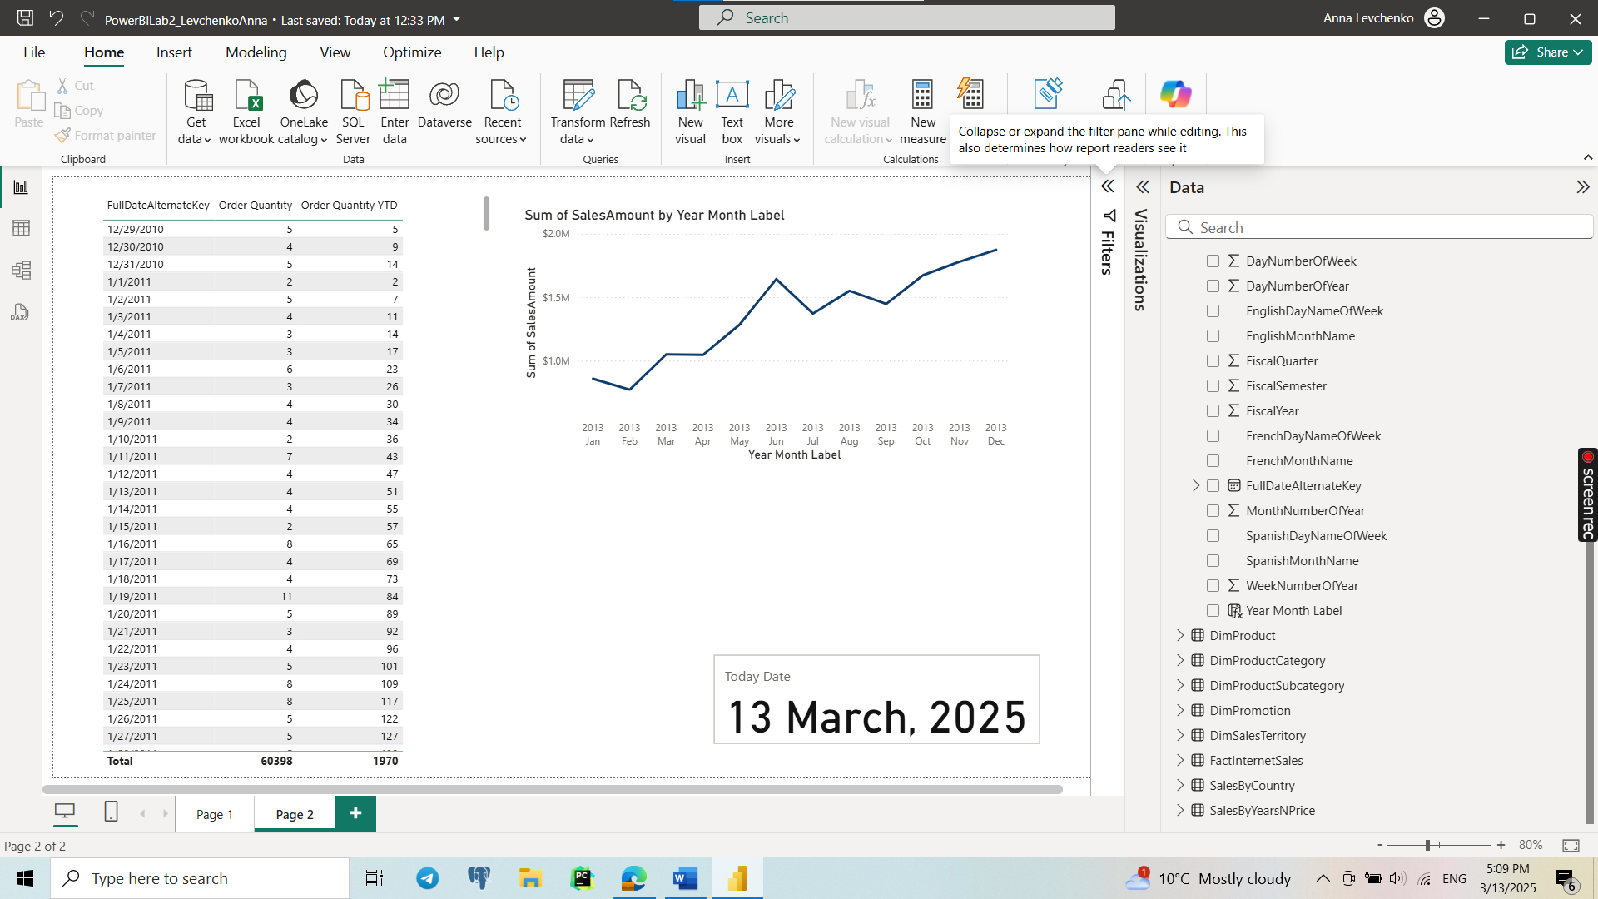

Task 1.3

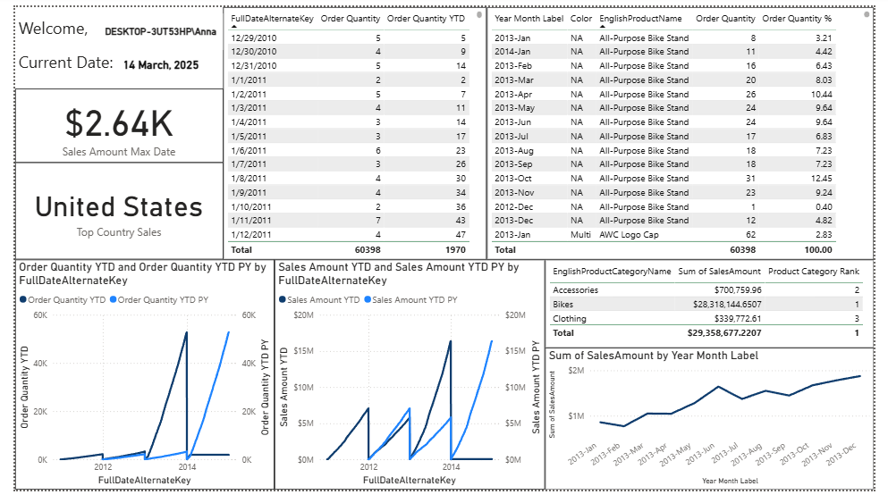

5) I used a Card for visualization. This method ensures that we always see the most recent sales data dynamically. If the dataset updates, it will automatically reflect the latest sales value.

6) TOPN(1) dynamically filters the country with the highest sales. It updates automatically if the data changes. I used a Card for visualization.

7) RANKX Function: The RANKX function assigns a rank to each Product Category based on Sales Amount.

ALL(DimProductCategory) - Removes Filters: This ensures that all Product Categories are ranked globally, rather than being affected by external filters in the report.

CALCULATE(SUM(FactInternetSales[SalesAmount])) - Sales Calculation: This computes the total Sales Amount for each Product Category.

Sorting Order (DESC): Ensures the highest Sales Amount gets rank 1, the second-highest gets rank 2, and so on.

Ranking Style (DENSE): DENSE ranking avoids gaps in the ranking numbers. Example: If two categories tie for Rank 1, the next category will be Rank 2 (instead of Rank 3, which happens in "Standard" ranking).